Test Case: runTestMultipleTimes
Step 1 - Enter username and password and click to button Enter : Credentials Entered
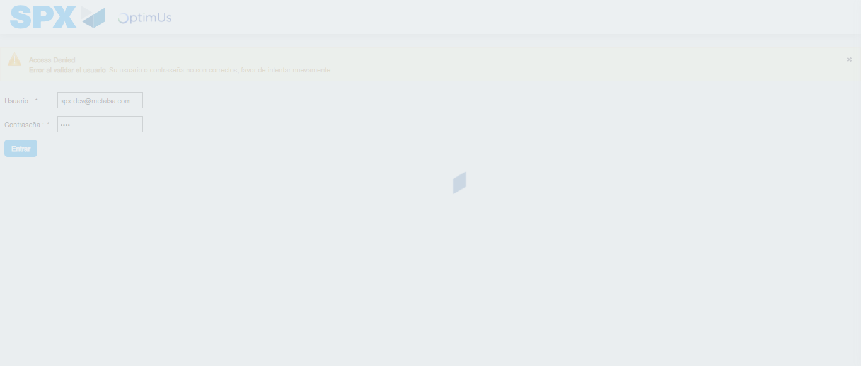Image file-name: QC_Testing-runTestMultipleTimes-dic. 03 2025, 09 28 24 a. m.

Step 2 - Select to UEN and Access to Administrador Roles Menu: UEN Correctly selected and Correct access
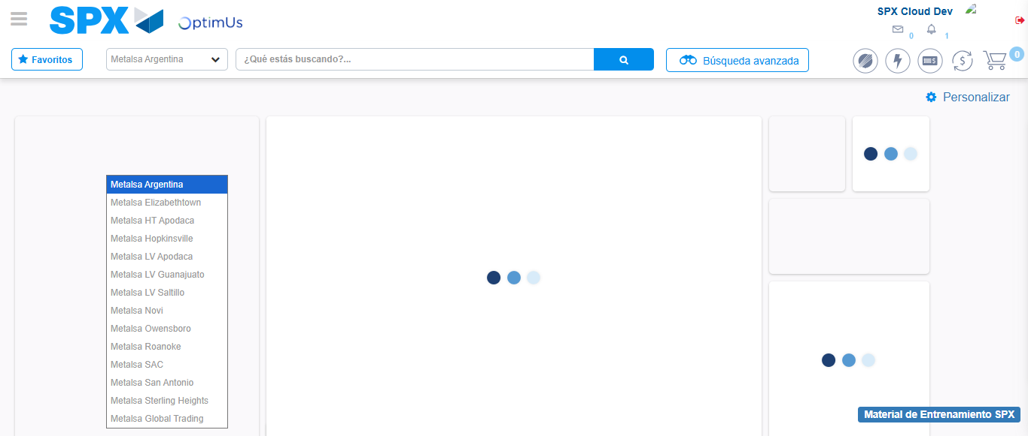Image file-name: QC_Testing-runTestMultipleTimes-dic. 03 2025, 09 28 28 a. m.

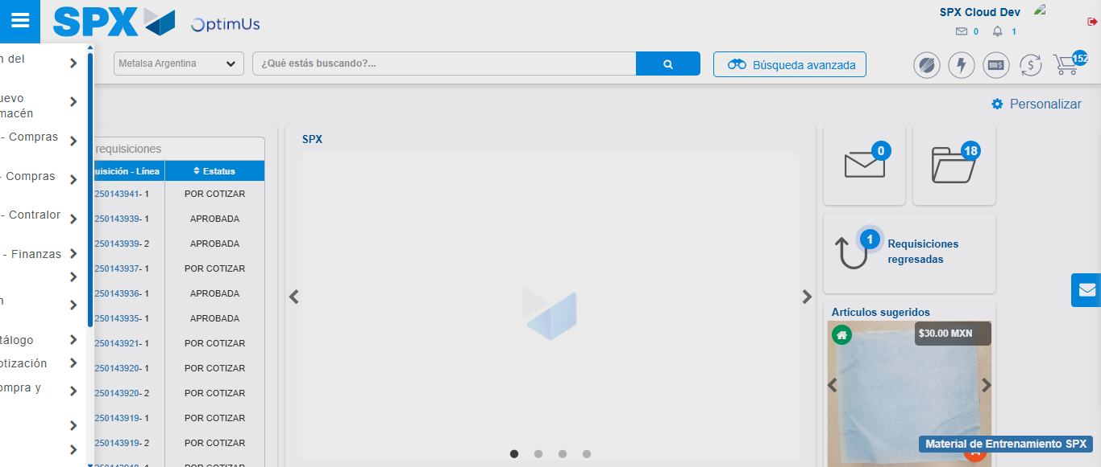Image file-name: QC_Testing-runTestMultipleTimes-dic. 03 2025, 09 28 29 a. m.

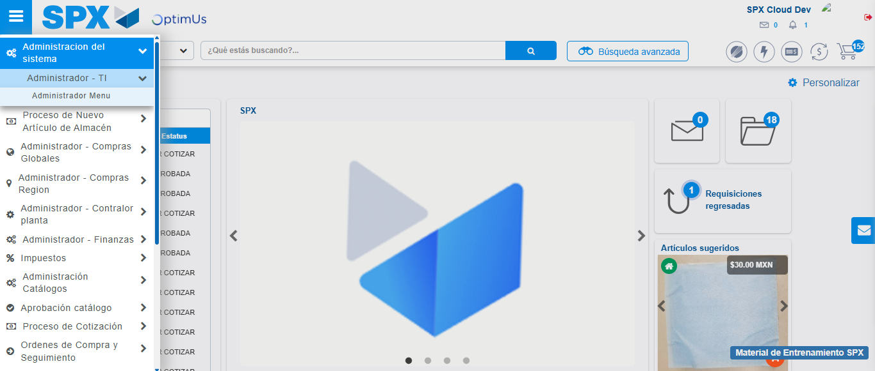Image file-name: QC_Testing-runTestMultipleTimes-dic. 03 2025, 09 28 30 a. m.

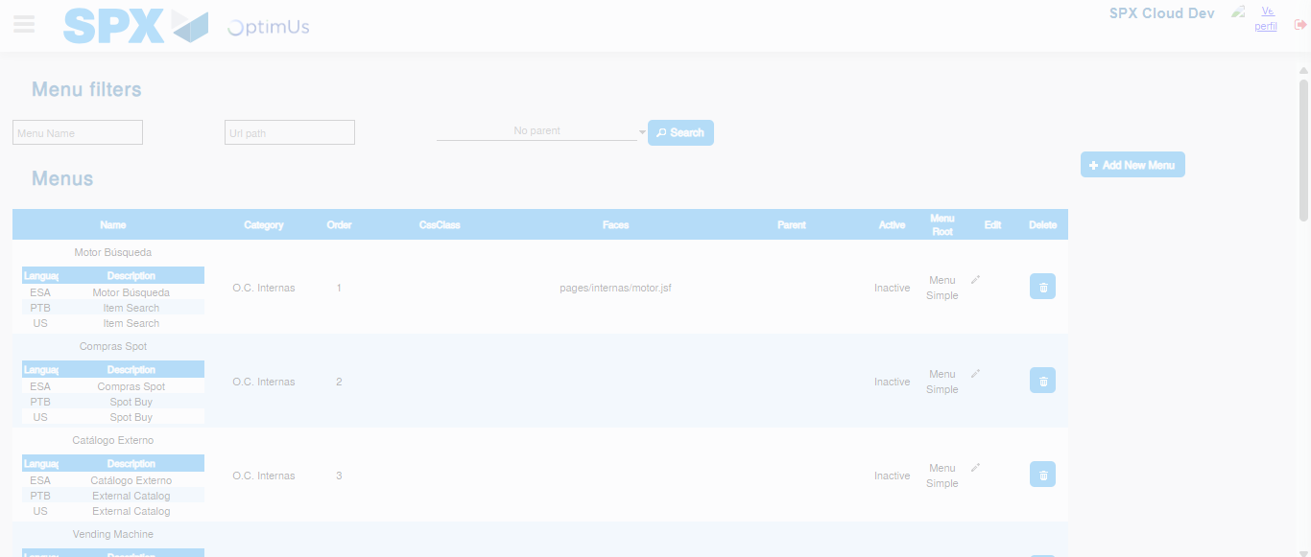Image file-name: QC_Testing-runTestMultipleTimes-dic. 03 2025, 09 28 33 a. m.

Step 3 - Perform a search with the URL Path filter: Successful search
Image file-name: QC_Testing-runTestMultipleTimes-dic. 03 2025, 09 28 33 a. m.

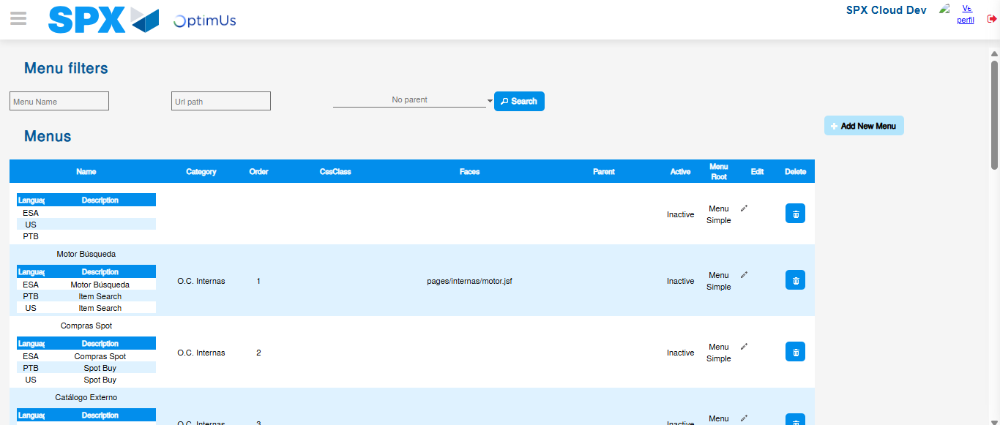Image file-name: QC_Testing-runTestMultipleTimes-dic. 03 2025, 09 28 37 a. m.

